Highlighting the prices which are less than 50 with red colour:

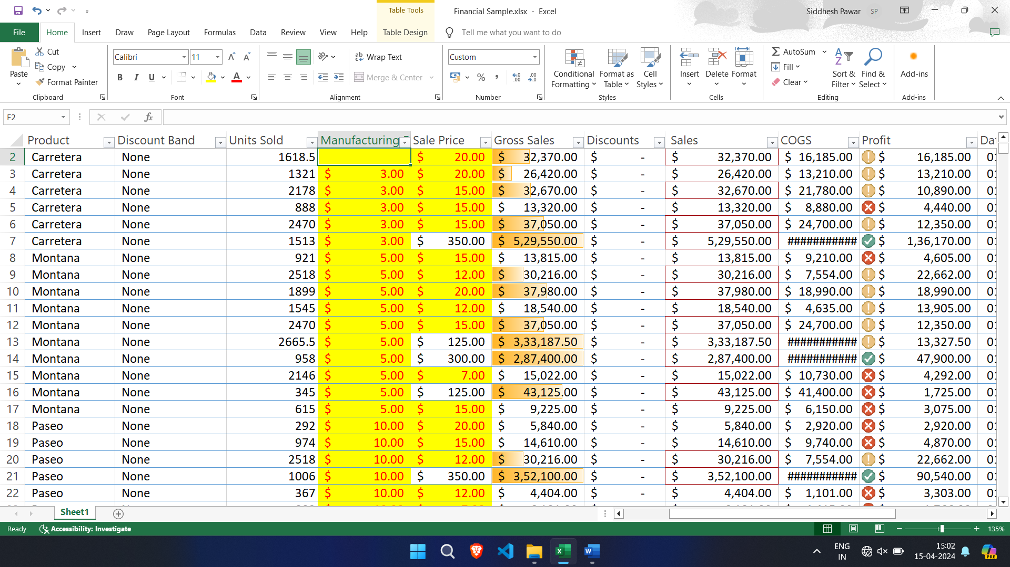

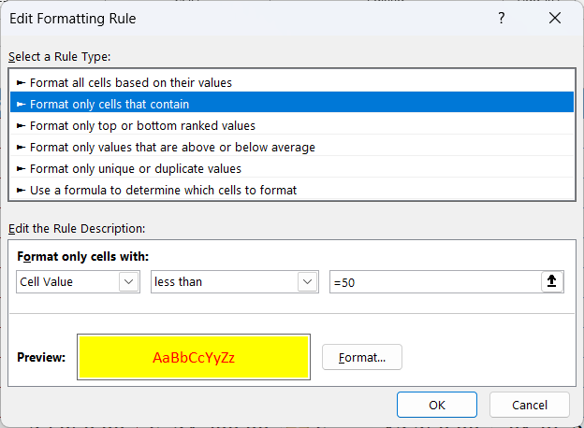

Highlighting ‘Sales’ value greater than 30000:



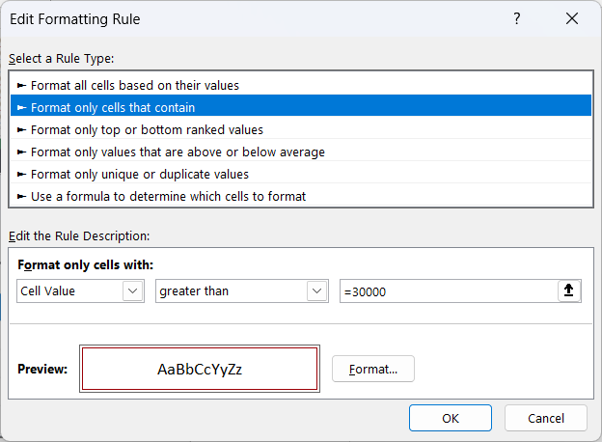

Use Shape for applying the rule on ‘Profit’ cell:



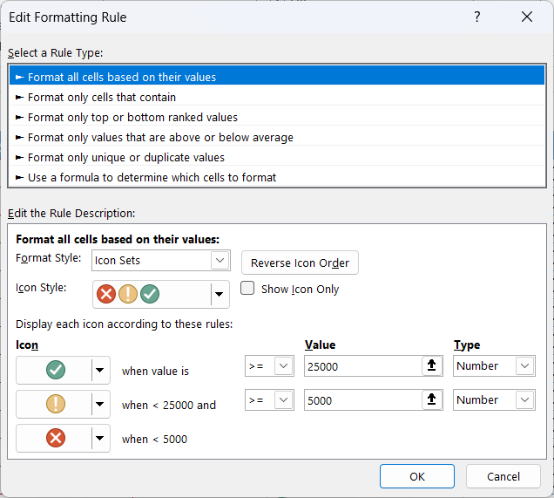

Using Data Bars:



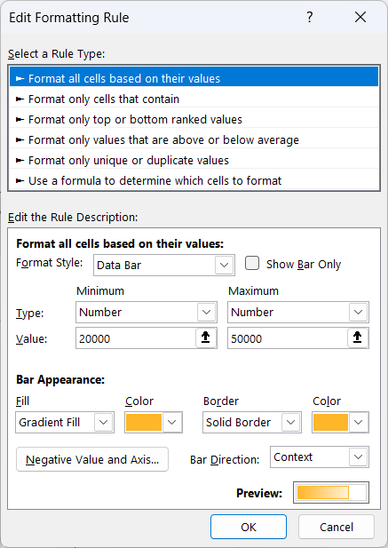

Creating a pivot table to analyze and summarize data:

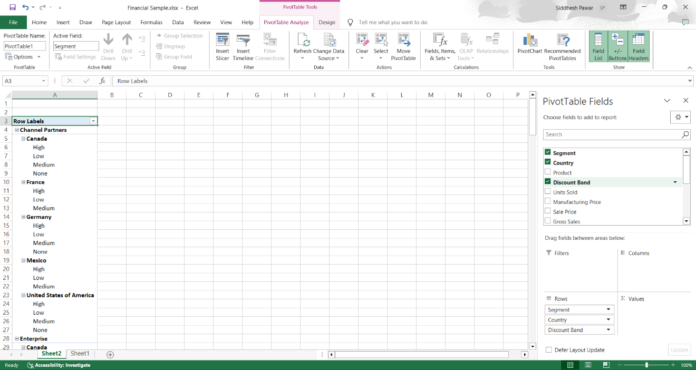

**Use VLOOKUP function to retrieve information from a different worksheet or table:**

Excel file:

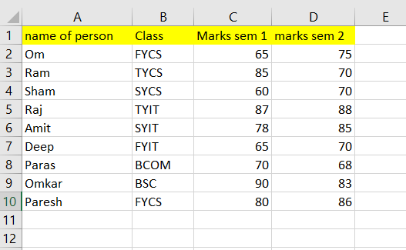

Applying VLOOKUP formula:

Formula is [=VLOOKUP(<select column name of person>,<Selecet Whole Excel ada table >, <Select the column where you fill sem 1 marks(here I was selected colum 3), 0 >]

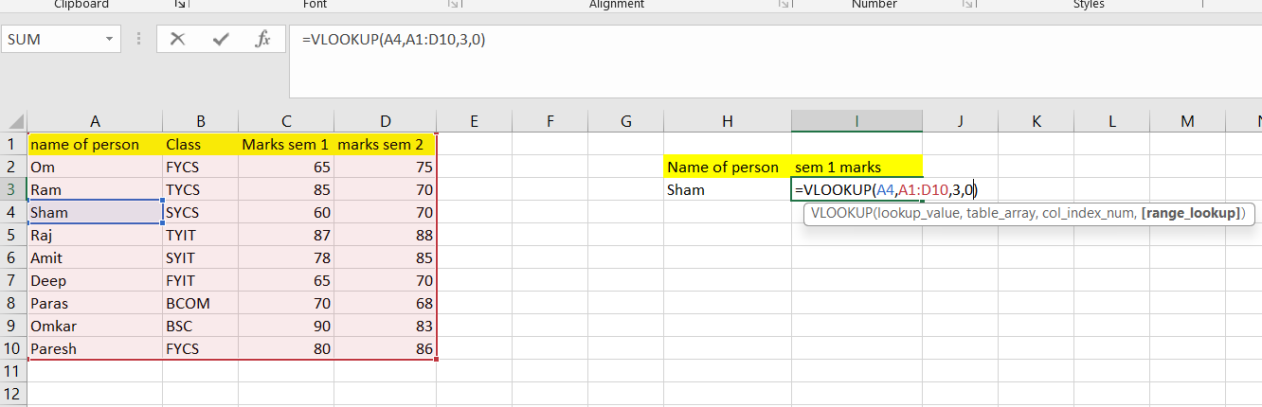

Output here we get 60

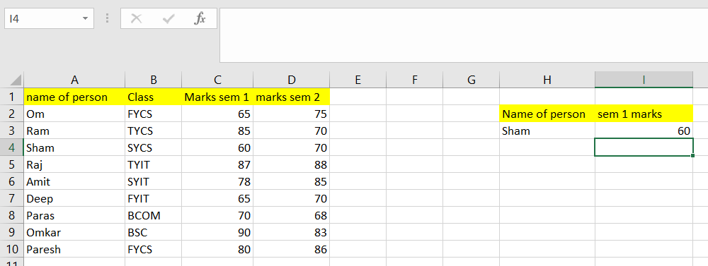

If we want to marks of person in both sem and total of that person then apply following formula

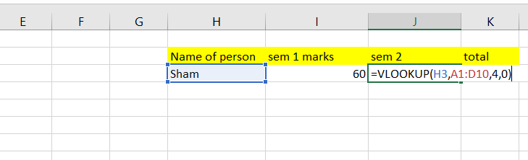 

IF I Change Student Name Marks also be change For total apply SUM Formula

 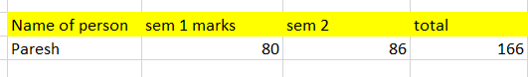

Performing What-if analysis

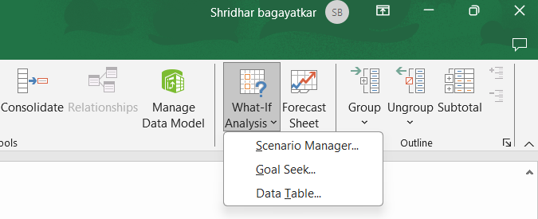

Goal Seek

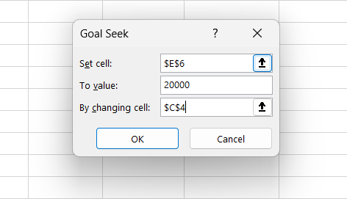

After performing What if analysis Change Value automatically

